CS577 : Project Report

|  |  |
| --- | --- |
| Project Number : | Project 16 |
| Group Number : | 23 |
| Name of the Top Module : | crypto_sign_keypair |
| Link for the Git Repo : | <https://github.com/ExplosionArt/picnic_keypair_16> |

|  |  |
| --- | --- |
| Group Members | Roll Numbers |
| Ajitem Joshi | 194101021 |
| Dhananjay Shukla | 194101018 |
| Abhay Chandra | 194101002 |

# 

# **INTRODUCTION**

# PHASE-1

## Running the algorithm

#### 1.1 Simulation screenshot

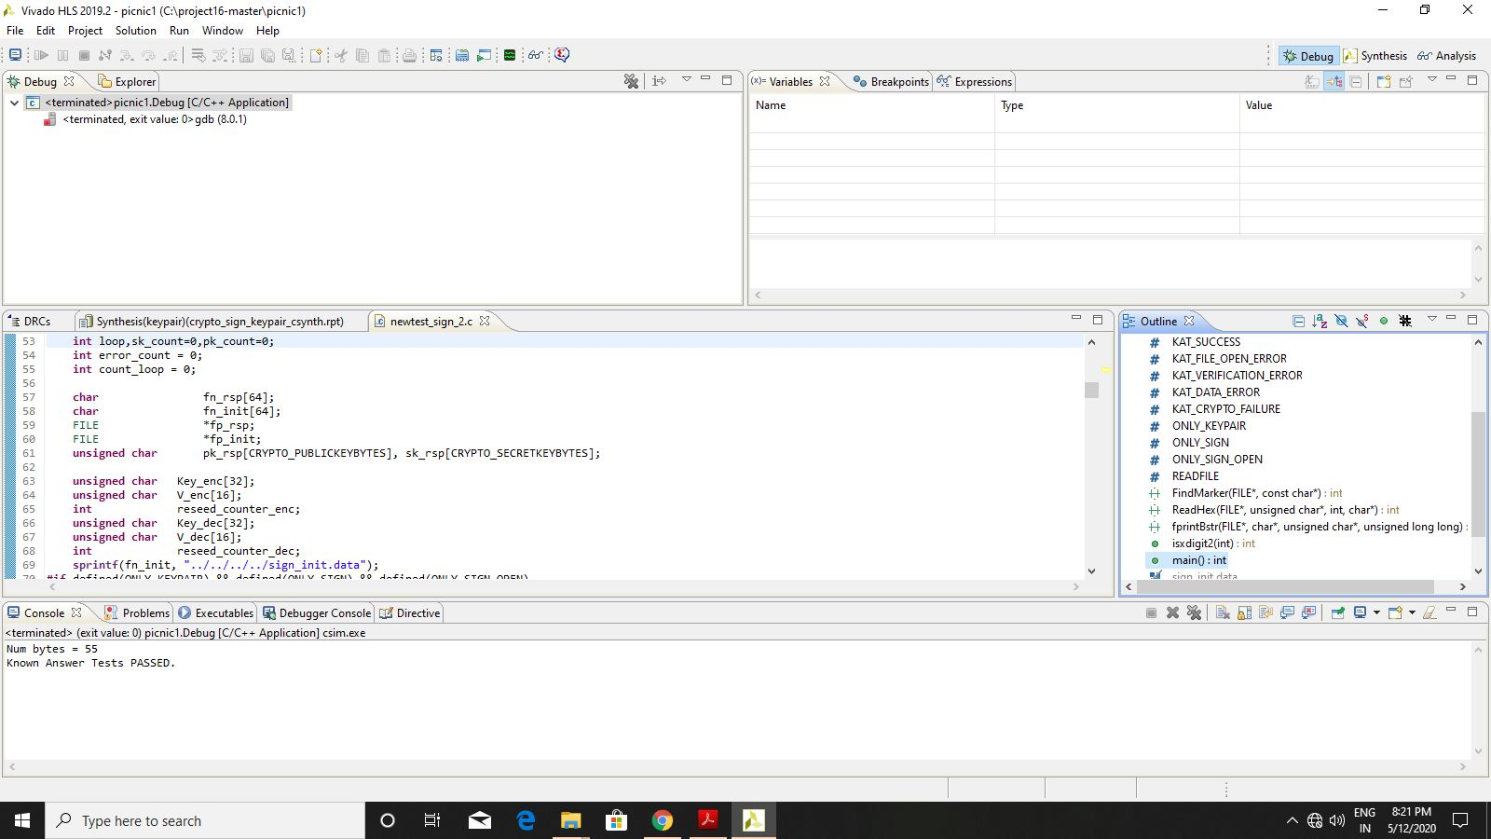

#### 

#### 

#### 

#### 

#### 

#### 

#### 

#### 

#### 

#### 1.2 Synthesis screenshot

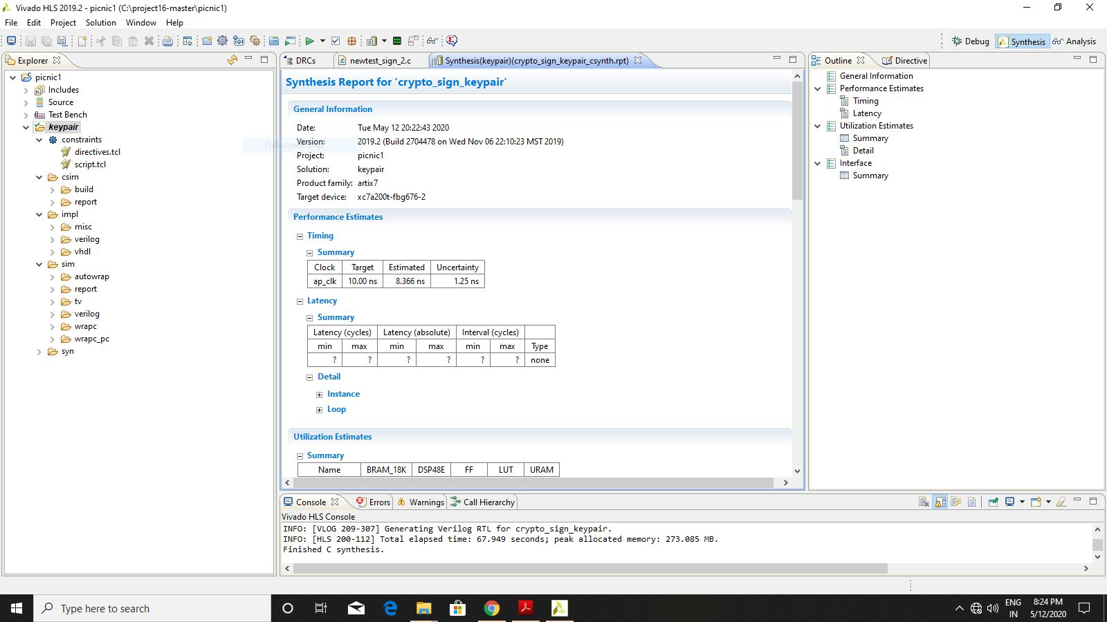

#### 1.3 C/RTL Co-Simulation Screenshot

#### 

## 

## **FLOWCHART**

## 

**Description:**

* The top function **crypto_sign_keypair()** is called with two parameters pk and sk which are public key and secret key(or private key) respectively which are initially empty.
* First Task is public key and secret key generation. Paramset is initialized with pre-defined values such as number of rounds, number of S boxes, message digest bytes etc.
* A random private key is generated from the **randombytes()** function which uses AES-256 encryption. A slightly modified version of AES from Open-SSL Library is used for encryption which performs S-box substitution and P-box permutations and Key is generated.
* A random block of plaintext is also generated similarly.
* From the given plaintext, a ciphertext is now generated which involves the **LowMCEnc** cipher. This function fundamentally performs operations such as matrix multiplication and XOR
* Finally, these generated public and private keys are written into corresponding buffers for further processing.

## 

## **RESULT**

#### 

|  |  |  |  |  |  |  |  |
| --- | --- | --- | --- | --- | --- | --- | --- |
| FPGA Part | Name of Top Module | FF | LUT | BRAM | DSP | Latency | II |
| Artix - 7 | crypto_sign_keypair | 1939 | 11120 | 82 | 0 | 125591 | - |

#### 

# 

# 

# 

# 

# 

# 

# 

# 

# **PHASE-2 and 3**

The target FPGA board is **Artix-7 board**

|  |  |  |  |  |  |  |  |  |  |
| --- | --- | --- | --- | --- | --- | --- | --- | --- | --- |
| Benchmark | Type  (Area /Latency) |  | Resource Utilization | | | | Latency | | Major  Optimizations |
| BRAM | LUT | FF | DSP | URAM | No of Clock cycle/latency | Clock period |
| Baseline | - | 82 | 11120 | 1939 | 0 | 0 | 125591 | 10 | - |
| Optimization 1 | Latency | 92 | 24648 | 5113 | 0 | 0 | 89532 | 10 | Loop Unrolling, Loop Flattening, Dead Code Elimination, Pipelining. |
| Optimization 2 | Area | 78 | 10288 | 2371 | 0 | 0 | 135720 | 10 | Loop rolling, Pipelining, Dead Code Elimination |

# **Optimization 1:** In the case of optimization 1, the major optimizations are Loop Unrolling, Loop Flattening, Dead Code Elimination, and Pipelining.

# Vivado HLS automatically takes advantage of parallelism i.e it will schedule operations to start as soon as they can. However, in case of rolled loops, operations are executed serially. To take advantage of parallelizability , Loops are unrolled.

# There can be certain areas in the code whose removal does not affect the results of the code. Such areas are called Dead Code. Removal of Dead code shrinks program size as well prevents execution of irrelevant operations, thus saving on execution time.

# Loop flattening involves converting nested loops into a single loop with the corresponding changes made to the outer loop. This inturn reduces the number of control blocks and optimizes latency.

# Pipelining reduces the initiation interval by allowing concurrent execution of operations, thus reducing the latency of the code. However, dependencies can sometimes hamper the performance of pipelines over unrolling.

# **Optimization 2:** In the case of optimization 2, the major optimizations are Loop Rolling, Pipelining and Dead Code Elimination.

Loop rolling, opposite to unrolling, reduces the parallelism of the code. Parallelism comes at the cost of additional hardware utilization. Loop Rolling forces sharing of hardware thus reducing the area.

Dead Code elimination and pipelining are the same as optimization 1.